LOADING AND UNLOADING FROM AWS

Before starting loading and unloading from AWS, Please create an AWS free tier account
You can refer any YouTube video on how to create a free trial account in AWS
Let us create a S3 bucket in AWS
Go to home page and search S3
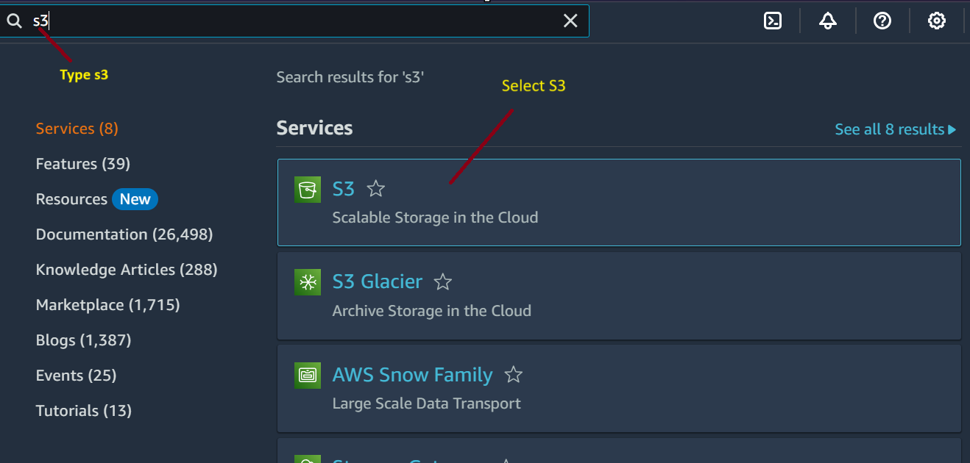
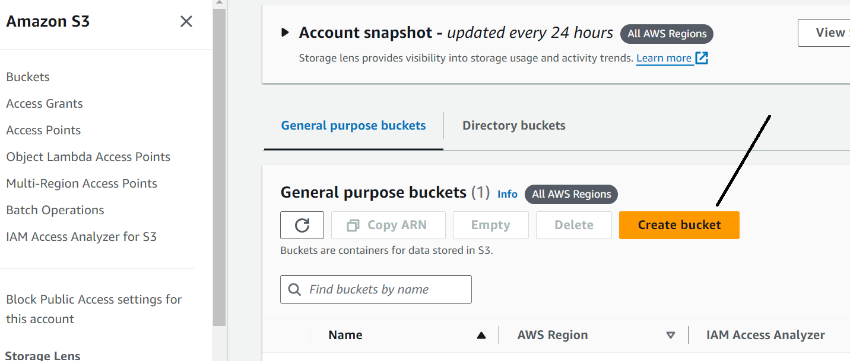

If both your AWS and snowflake are in same region, then its cost efficient
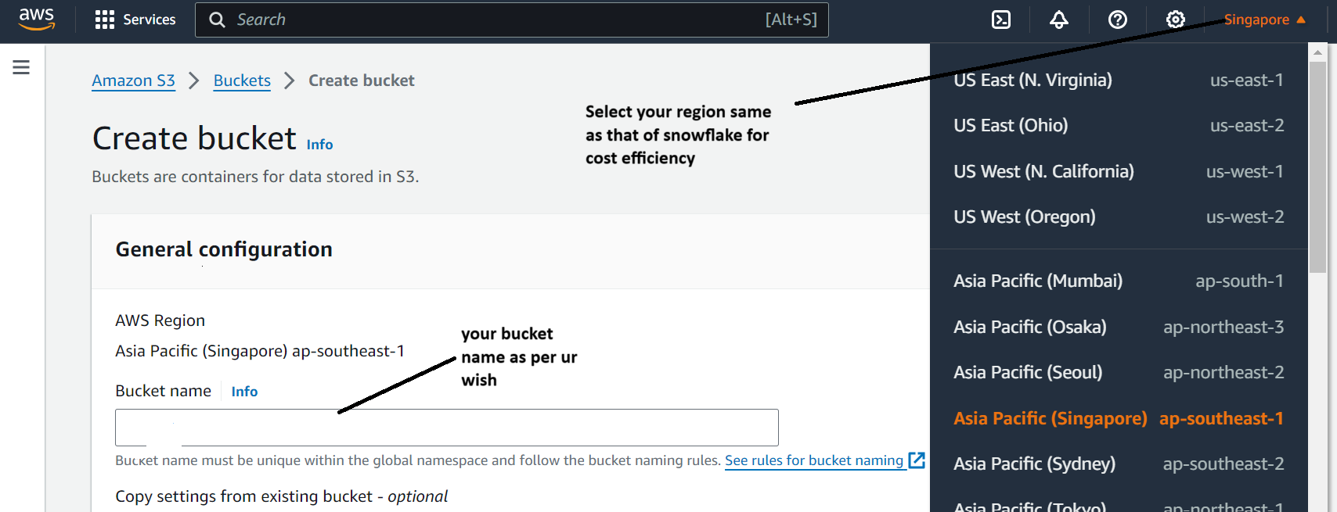
Now just click on create bucket at bottom
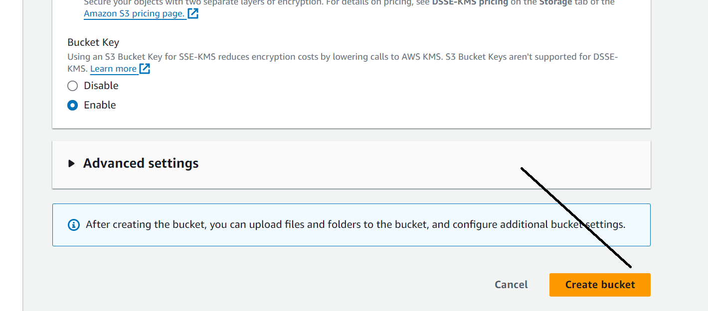
Now let’s open the bucket and create folders
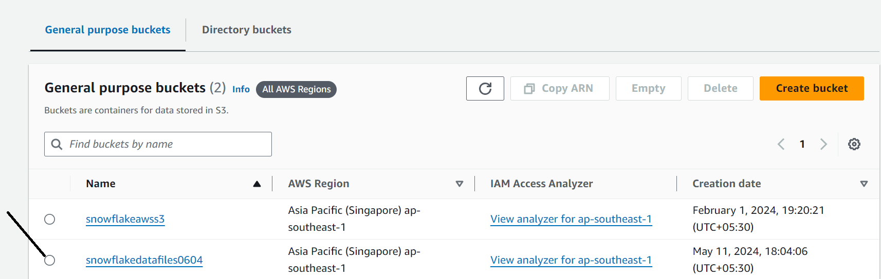
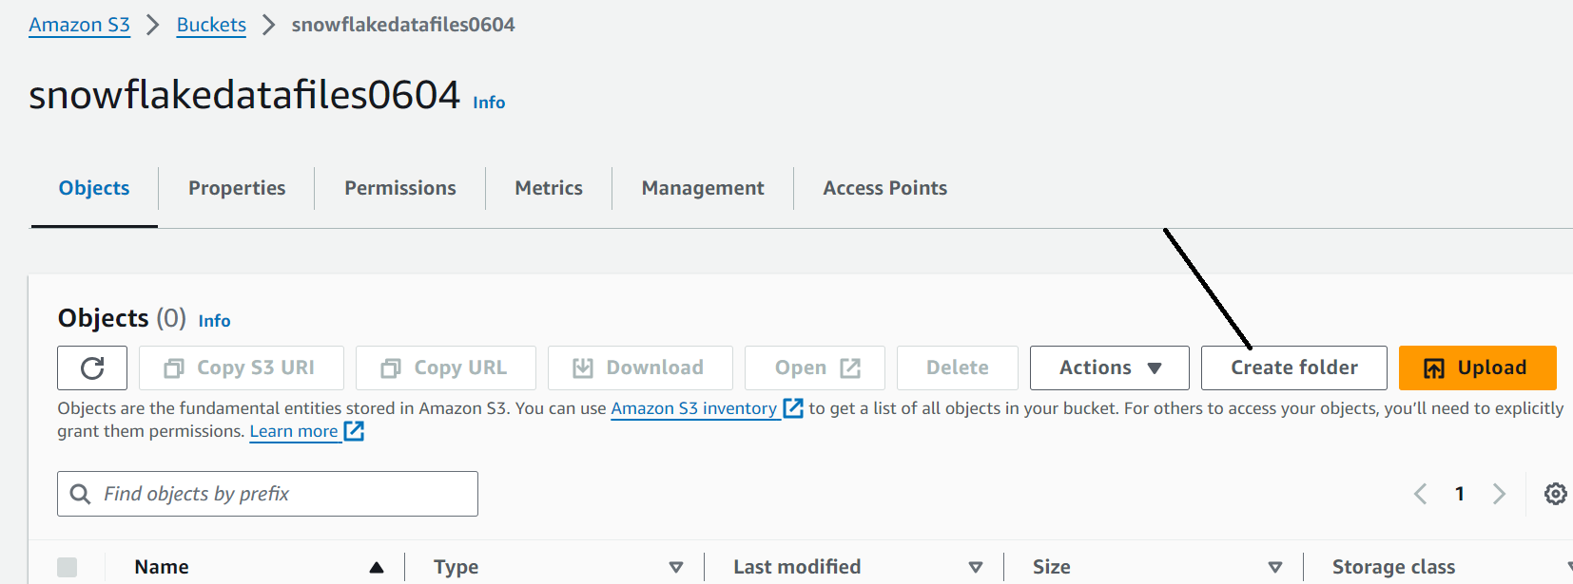
Give name of folder and click on create
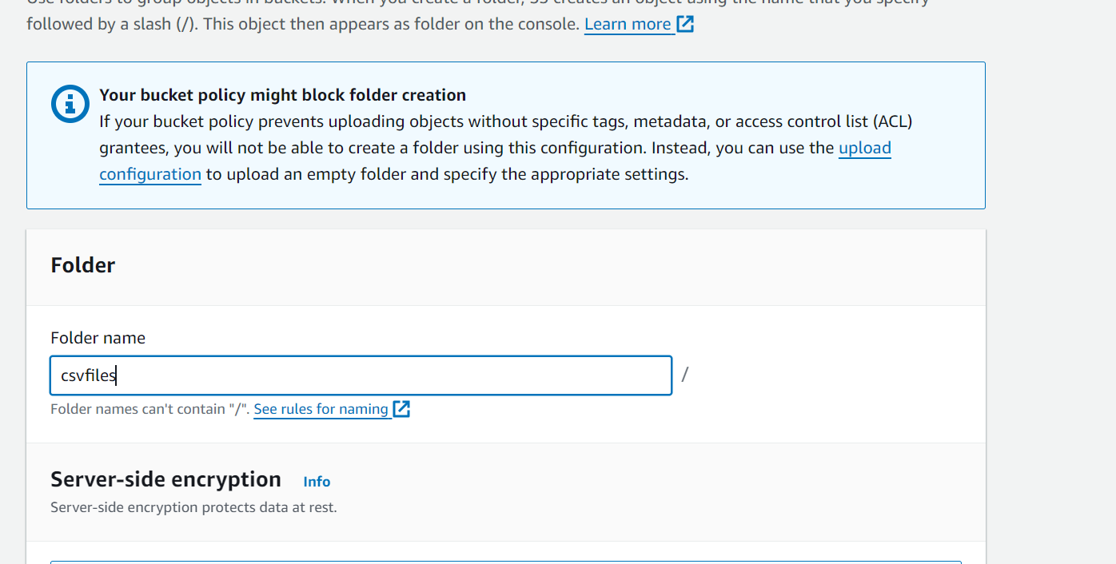
Add another folder named dataload inside csvfiles folder
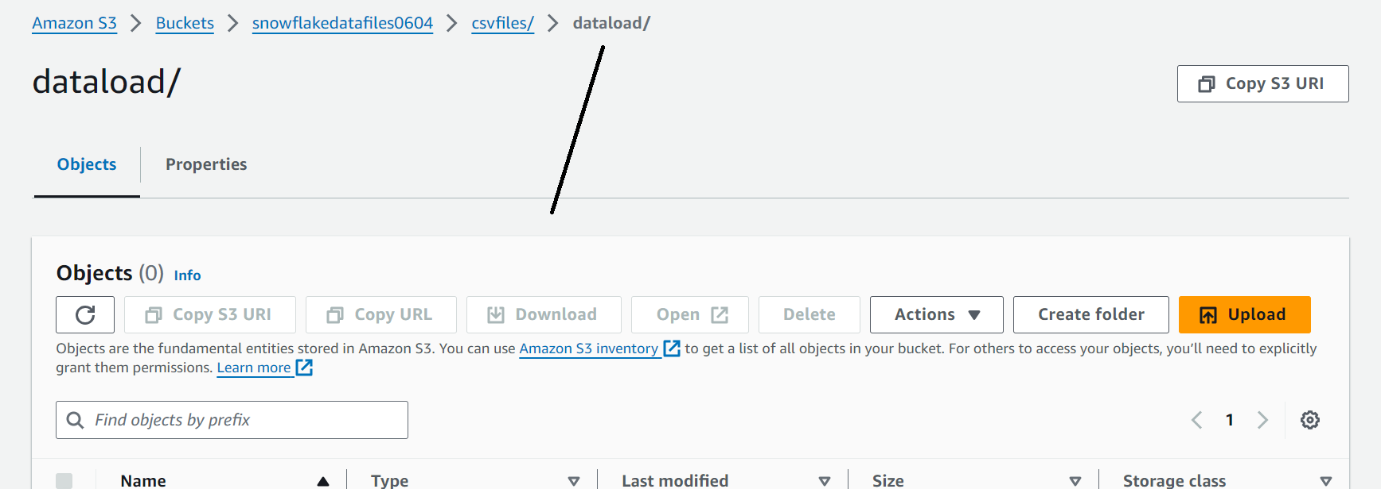
Now upload any file in it by clicking upload
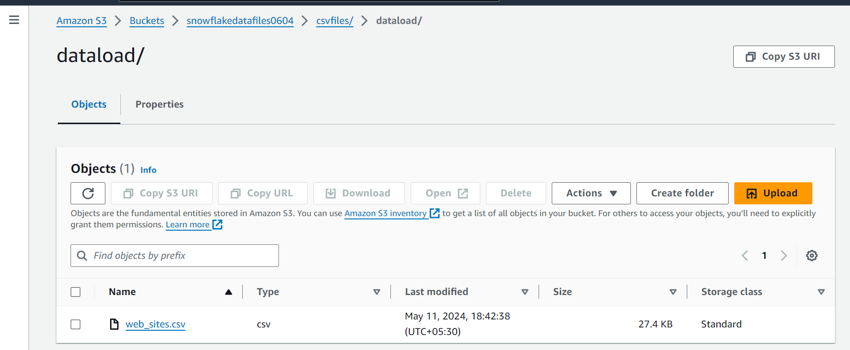
Now create another folder ‘dataunload’ under csv files
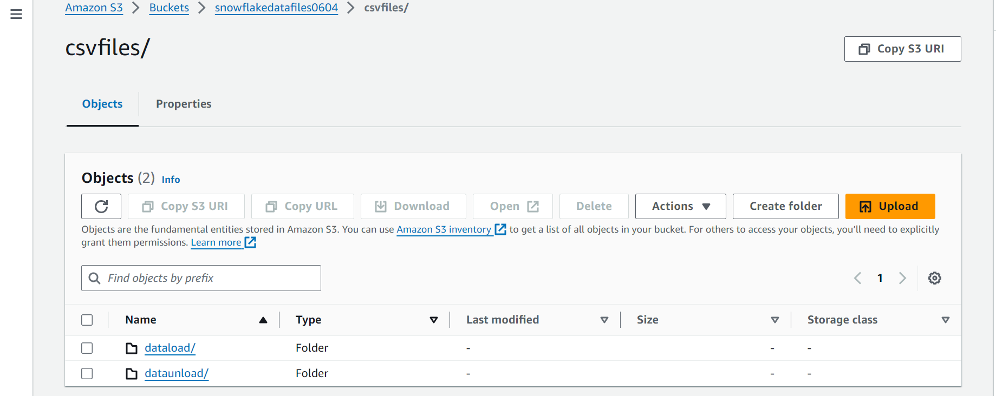
Now how does snowflake interact with AWS s3 bucket file??
So the interaction will be done by a role
Let’s create role in AWS
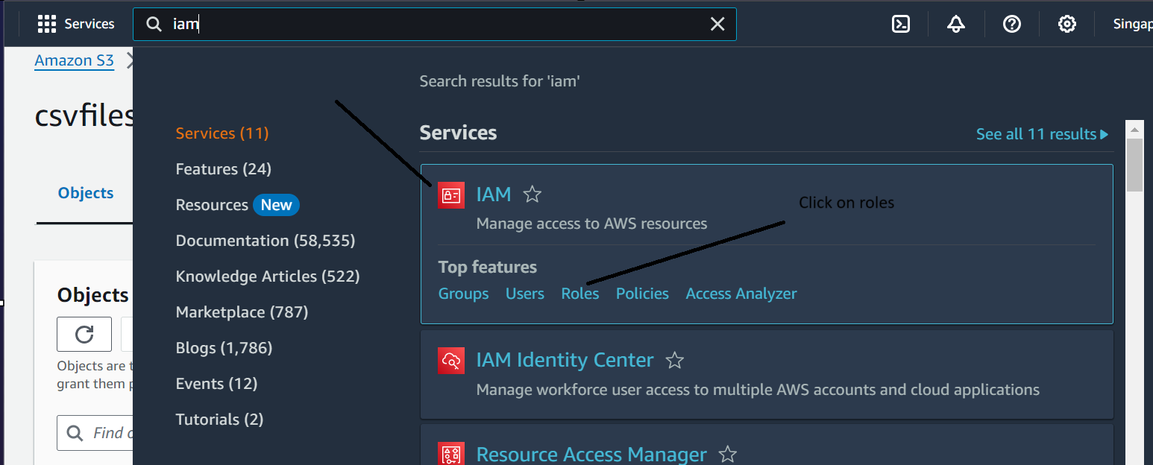
Click on create role
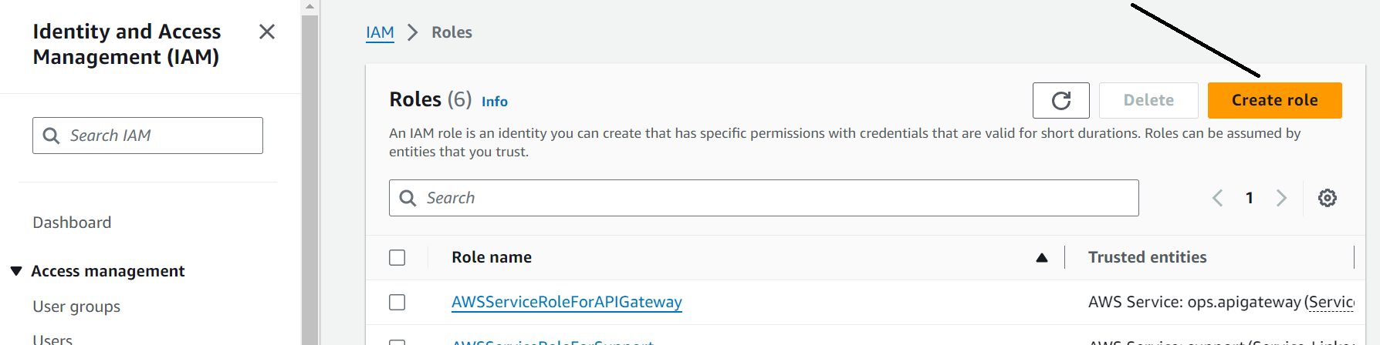
Click on aws account, choose options ‘Require external ID (Best practice when a third party will assume this role)’ and give external id as per your wish, I am giving AAAA
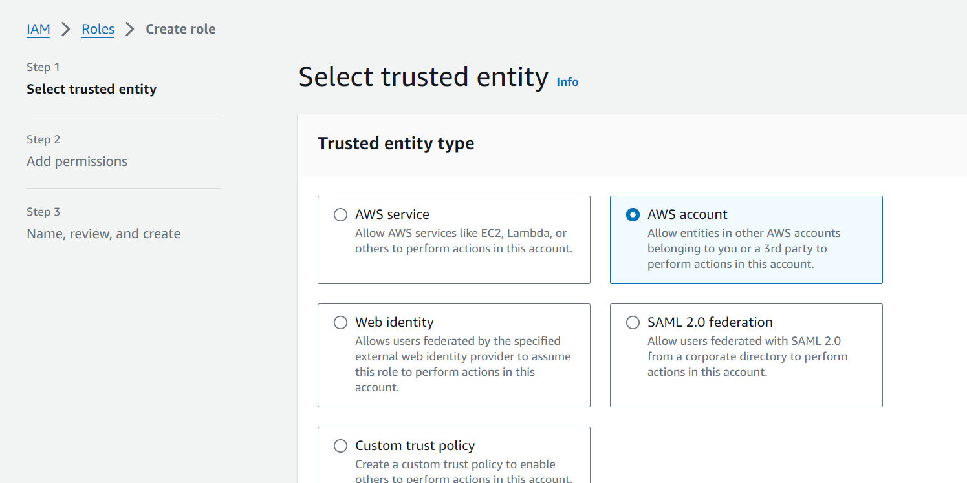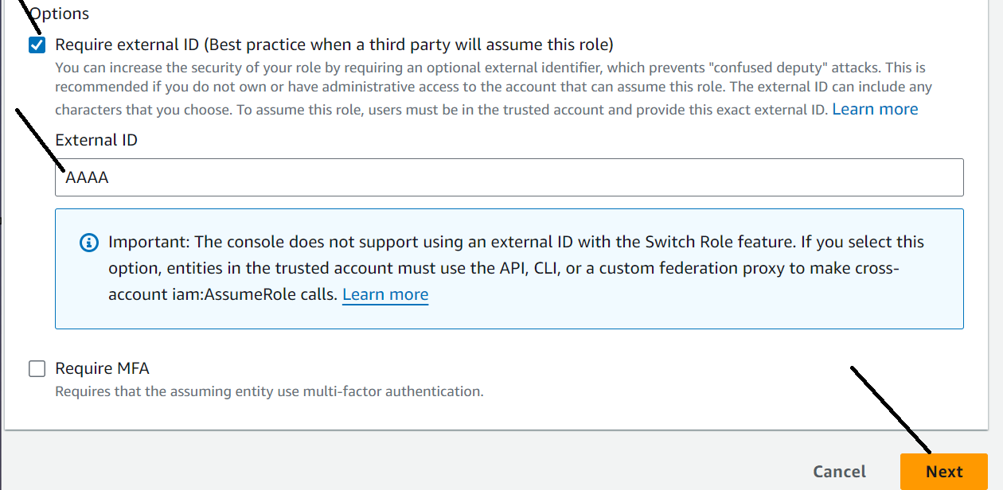
Now select amazon S3 full access and click next
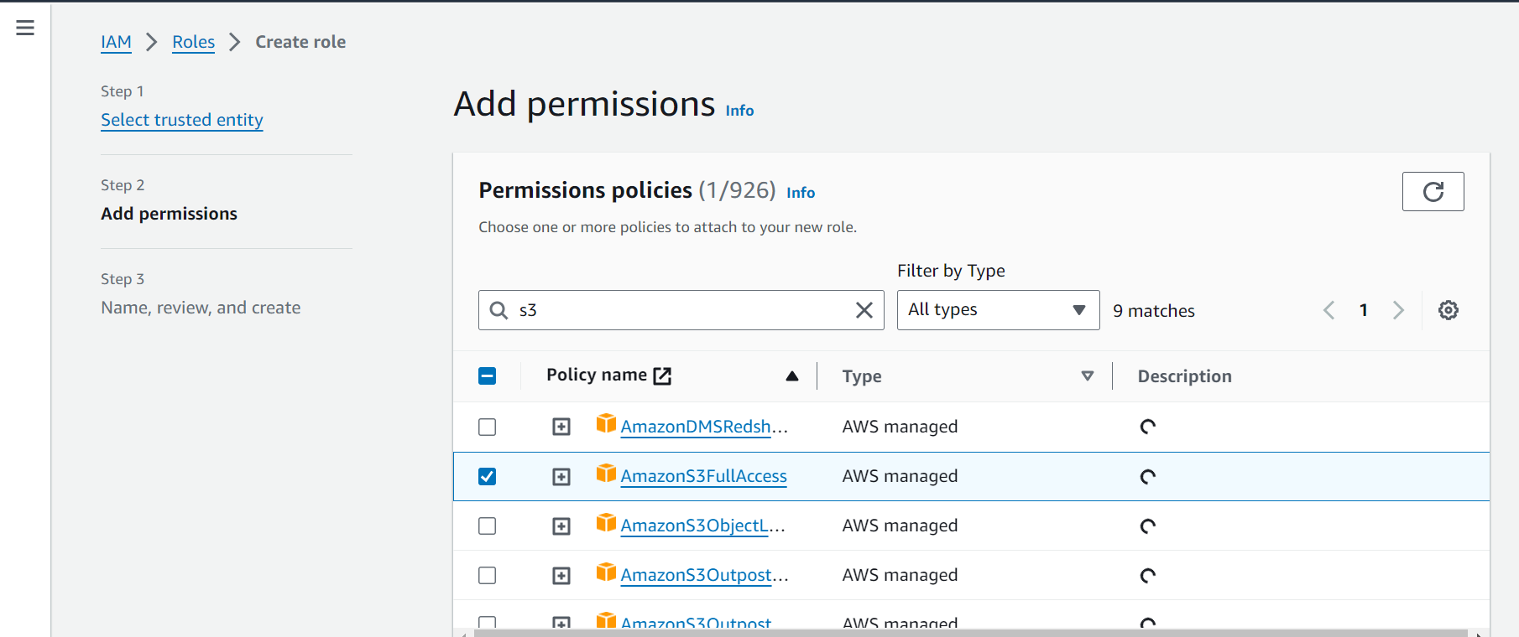

Give name and description, click create role
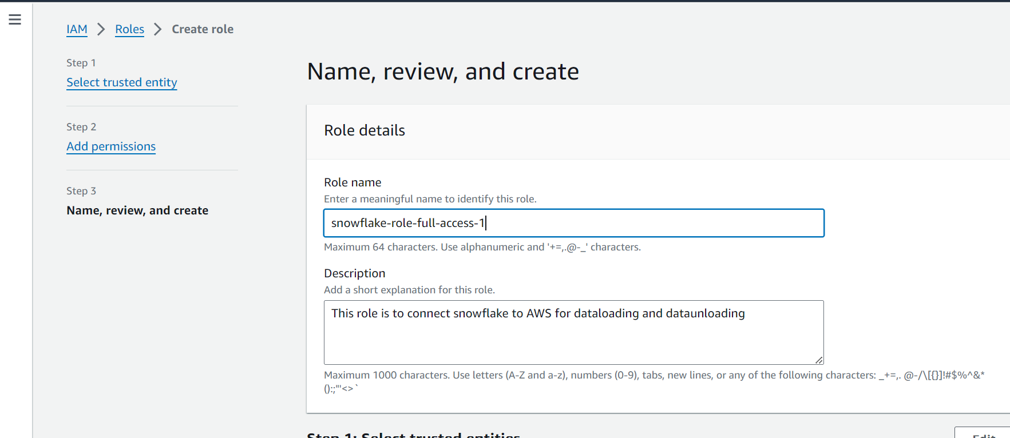
Open your role now and check
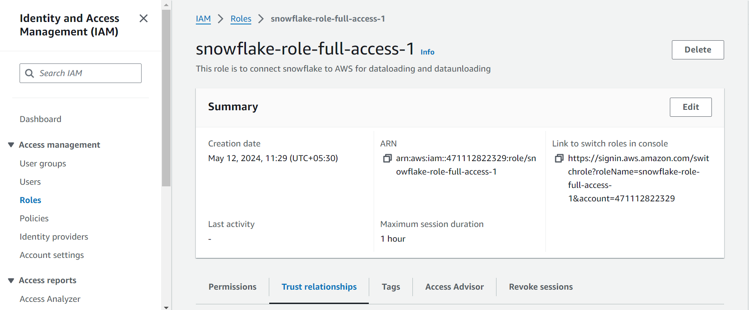

Storage Integration Object
Storage integration object is basically designed to interact with external cloud storage.
It stores the access management entity for external cloud storage.
So, storage integration object is a snowflake object which we create in snowflake database and we can see how it interact with AWS
In storage integration, we can put some cloud locations of S3

Let’s create an integration object in snowflake
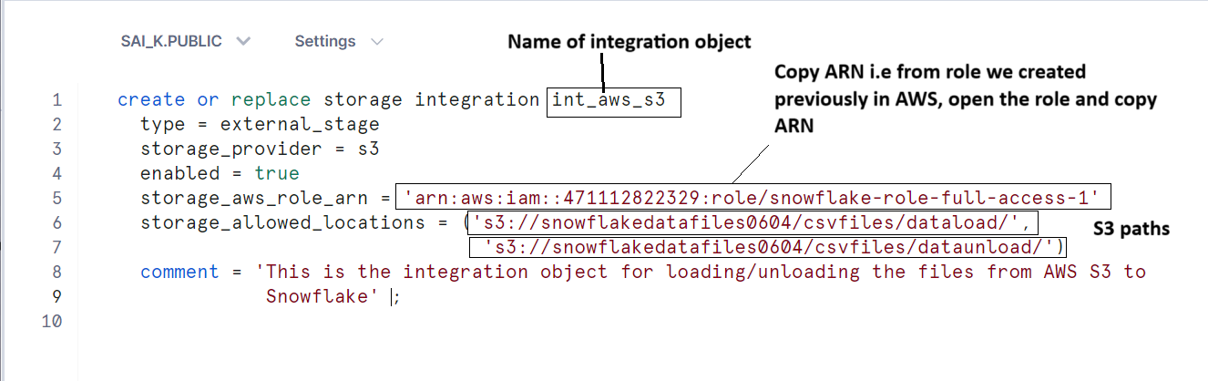
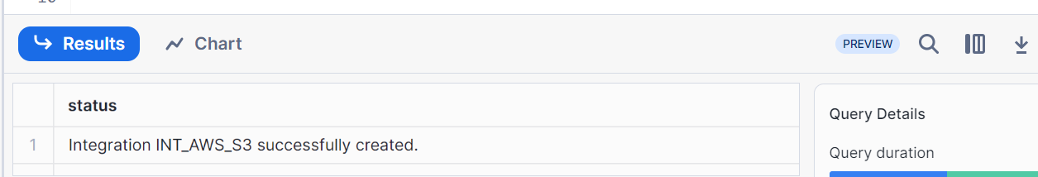
Describe Integration Object
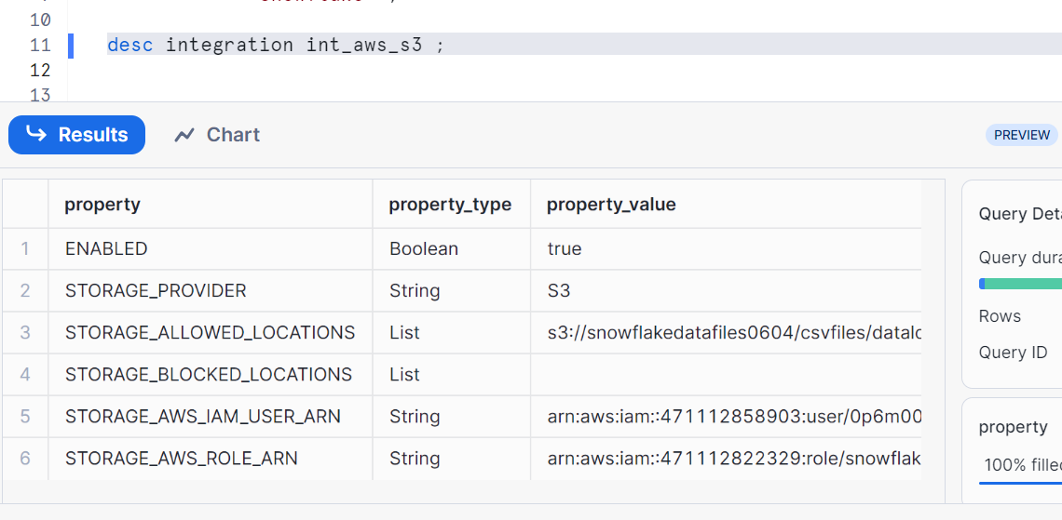
STORAGE_AWS_ROLE_ARN – This is our role which is identity access management information which we got from AWS
Now we have to connect integration object in snowflake and role in AWS
So take external ID and storage integration object (STORAGE_AWS_IAM_USER_ARN),
Let’s copy these into AWS role
Go to your role and click on trust relationships and edit trust policy
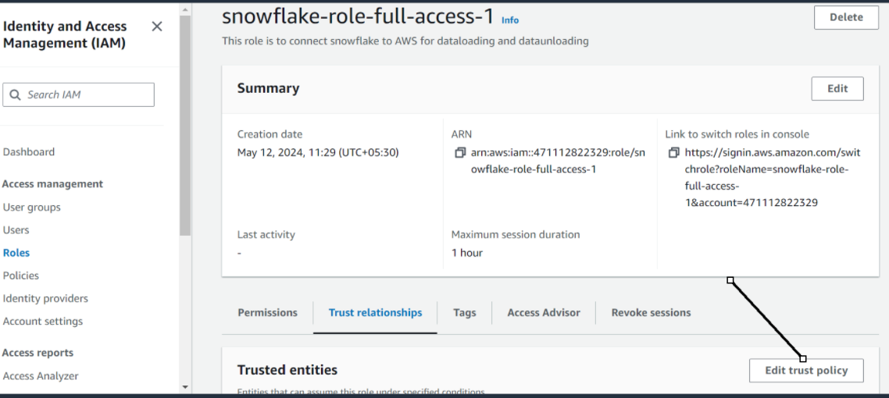
Edit your values as shown and click update policy
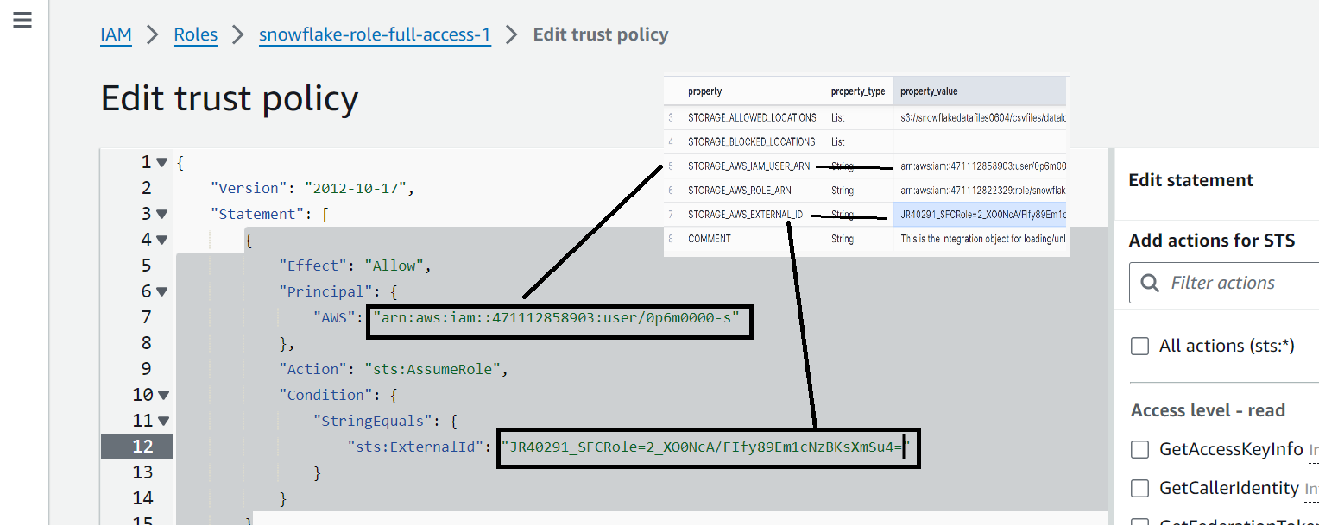

Now our integration object in snowflake is connected with AWS role

Now let’s load the file from AWS to snowflake table
Create file format (we had seen in earlier posts)
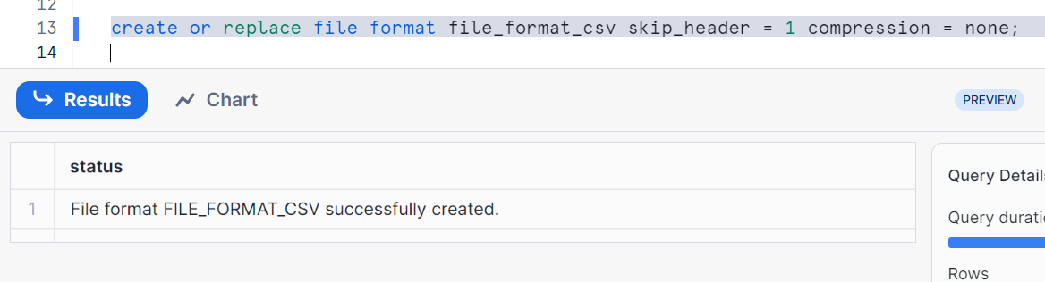
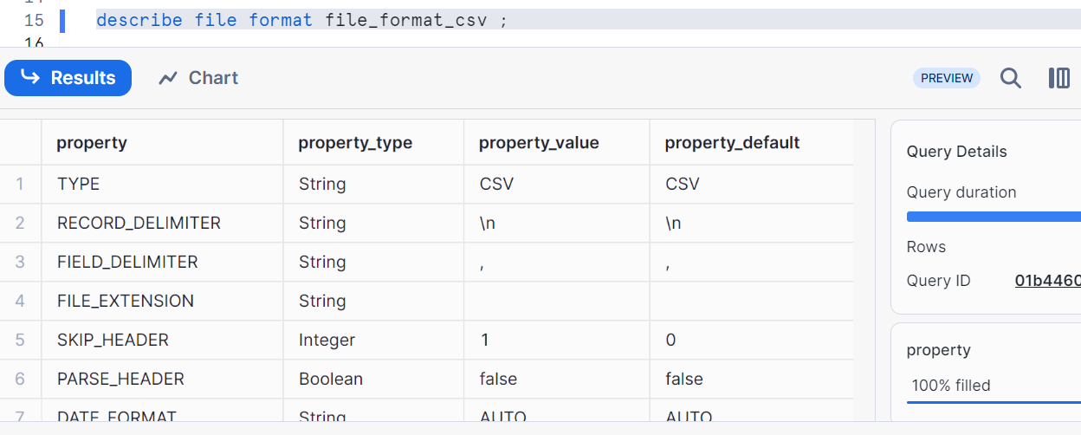
Create an external stage
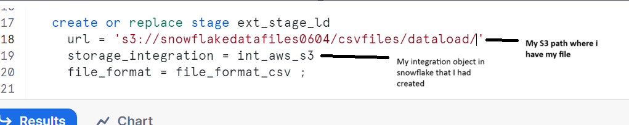

Check the files in our stage
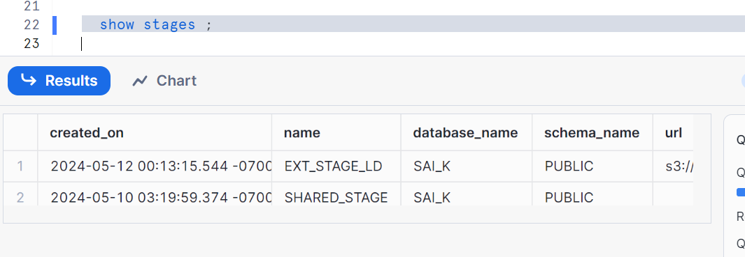
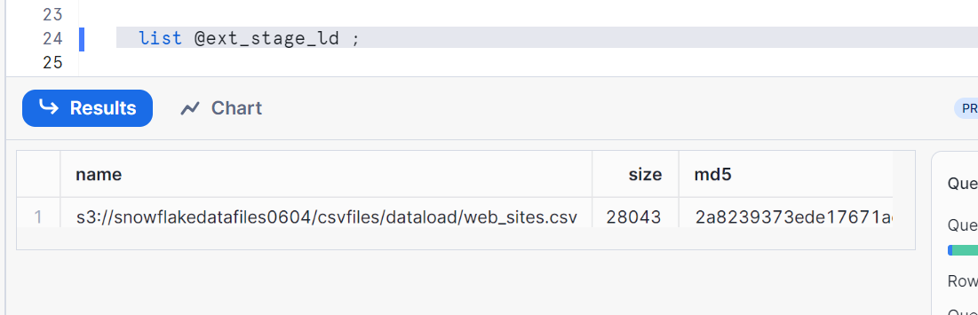
Now as you all know once you have your file in your stage, you know how to load the file into your snowflake table

Create the table to load (note: as per your file columns, create that many columns in your table)
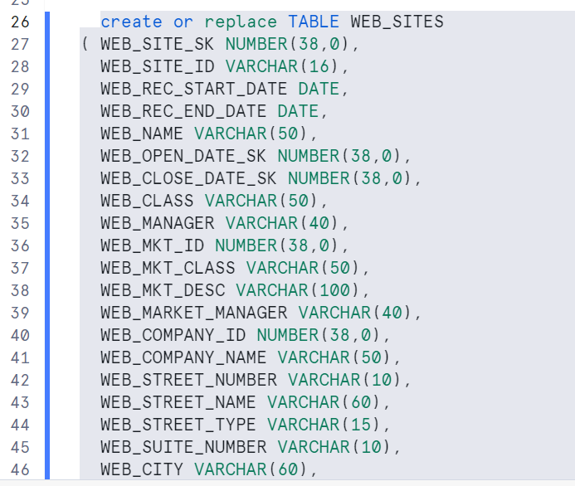
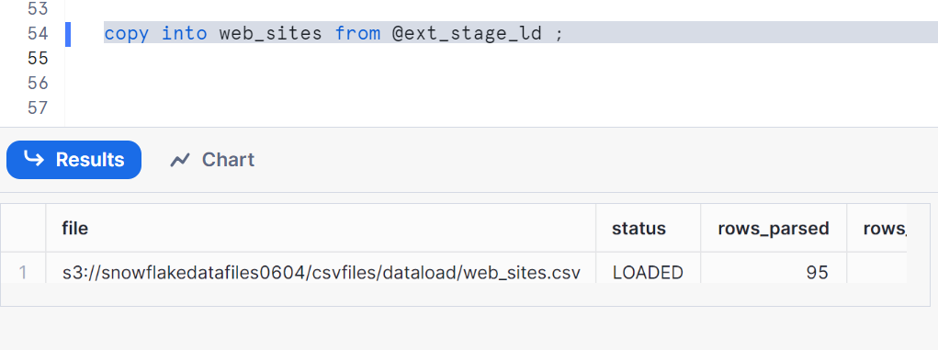
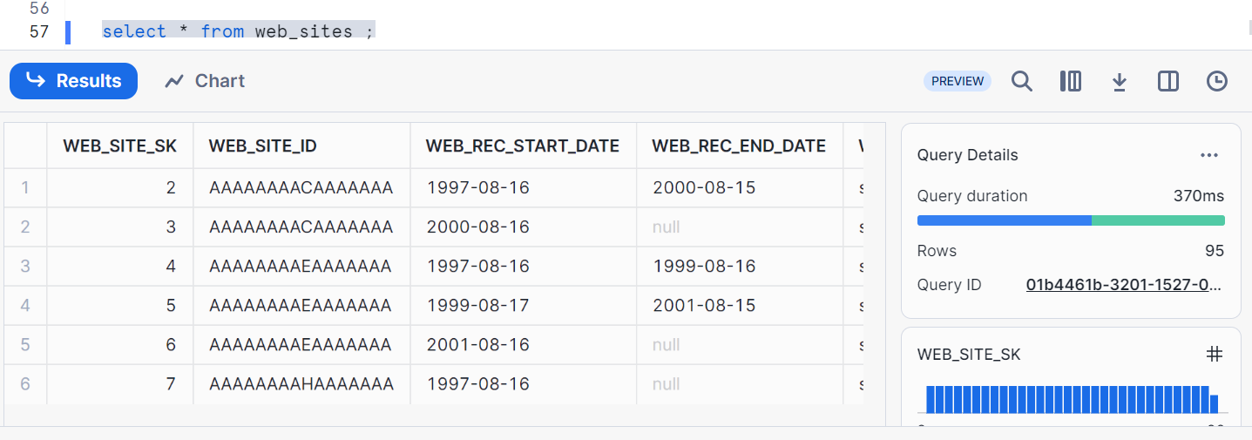

Now let’s unload the same snowflake table ‘websites’ back to S3 unload folder
Create external stage
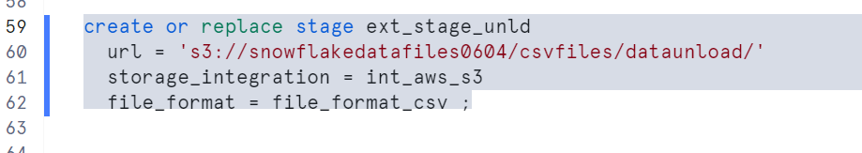
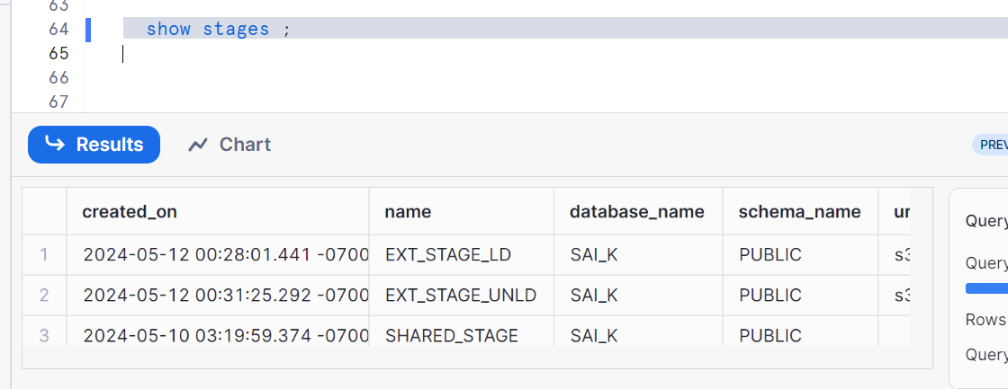
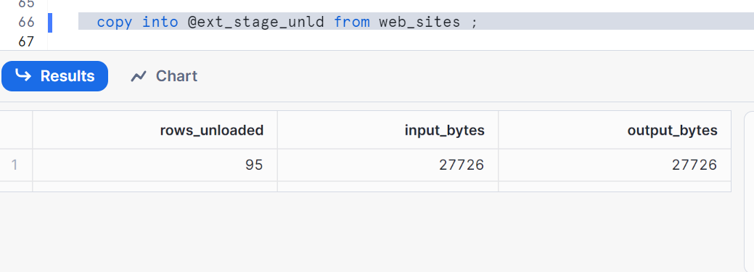
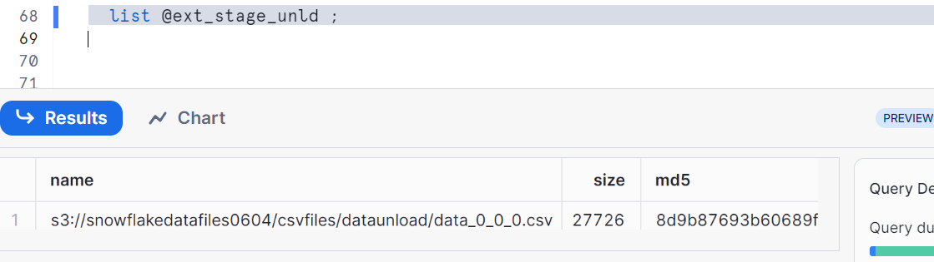
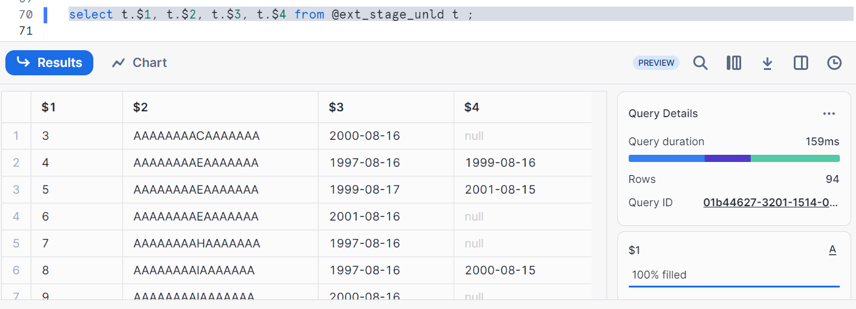

Check the file in your data unload folder
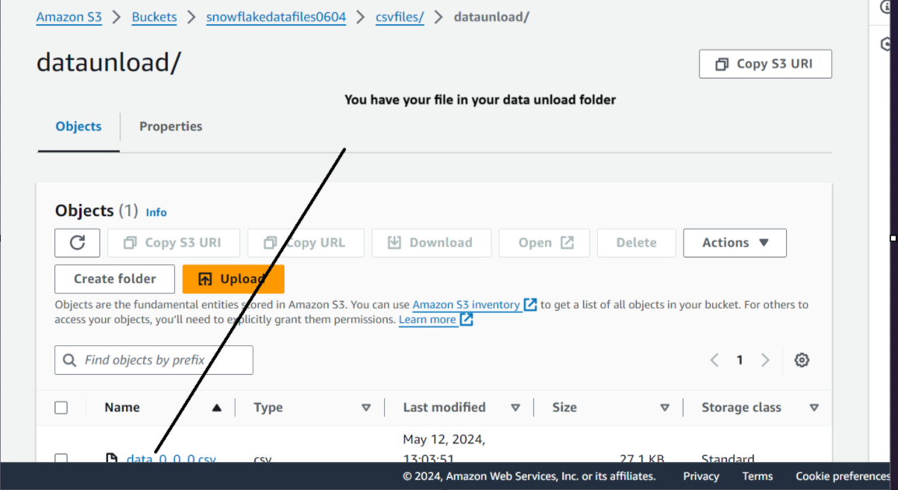

Now let’s clean up:
Remove @ext_stage_unld;
Drop stage ext_stage_unld;
Drop table web_sites;
Drop storage integration int_aws_s3;
Drop file format file_format_csv;
Drop stage ext_stage_ld;

